Csv reader program (using infos.csv)

read each row from a csv file and print it as a list of string

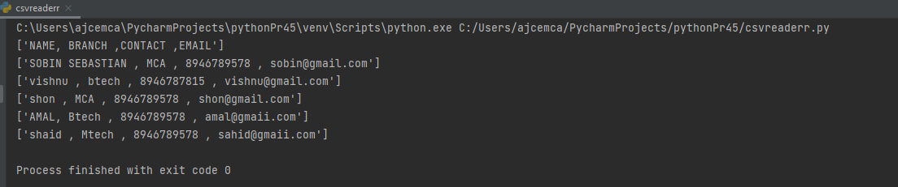

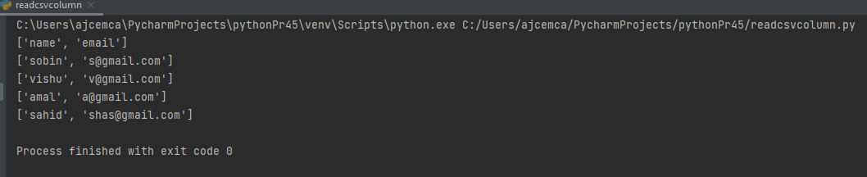

**AIM:** Write a Python program to write a Python dictionary to a csv file.

After writing the CSV file read the CSV file and display the content.

**CO5:**Create files and form regular expressions for effective search operations on

strings and files.

**PROGRAM:**

# Write a Python program to write a Python dictionary to a csv file.

# After writing the CSV file read the CSV file and display the content.

import csv

# Data to be inserted

data = [{'Name': 'John', 'Age': 25, 'Country': 'United States'},

{'Name': 'Mike', 'Age': 32, 'Country': 'Canada'},

{'Name': 'Sarah', 'Age': 35, 'Country': 'United Kingdom'}]

# Write to CSV file

with open('people.csv', 'w') as csvfile:

headernames = ['Name', 'Age', 'Country']

csvwriter = csv.DictWriter(csvfile, fieldnames=headernames)

csvwriter.writeheader()

for row in data:

csvwriter.writerow(row)

# Read from CSV file and print contents

with open('people.csv', 'r') as csvfile:

reader = csv.DictReader(csvfile)

for row in reader:

print(row)

**OUTPUT:**

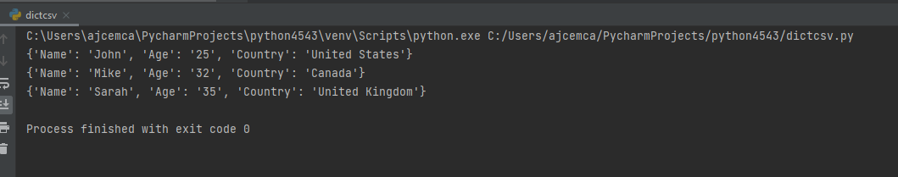

**AIM:** Write a Python program to read each row from a given csv file and

print a list of strings.

**C05:**Create files and form regular expressions for effective search operations on

strings and files.

**Program:**

# Program to read each row from a given csv file and print a list of strings.

import csv

# Open the CSV file

with open('people.csv', 'r') as f:

# Create a CSV reader

freader = csv.reader(f)

# Iterate over the rows of the CSV file

for row in freader:

# Print the row as a list of strings

print(row)

**Output:**

